MiSACWIS Project

CF16 – Find an Employee Screen Specification

Version 1.3

March 28, 2016

Prepared for:


120 N. Washington Square
SACWIS Project, 3rd Floor
Lansing, MI 48933

Prepared by:
Revision Log
Version | Date | A/D/C (Add, Delete, Change) | Author | Document Section # | Description
0.1 | 07/19/2011 |  | Matthew McElver |  | Initial version
0.2 | 12/19/2011 | C | S Kulkarni | 3.1.3 | Updated field grids
0.3 | 12/21/2011 | A | S Kulkarni | 3.1.2 | New To Be screen
0.4 | 01/03/2012 | A | S Kulkarni | 3.1.3 | Updated field grids
1.0 | 01/04/2012 | C | Mark Van Hoose | All | Iteration 10 Approved
1.1 | 03/07/2012 | C | Mark Van Hoose | 3.1.4 | Change Control 6030
1.2 | 08/02/2012 | C | Mark Van Hoose | 3.1.5 | Change Control 14854
1.3 | 03/28/2016 | Add | Robyn Pratt-Barr | 2.1.1 & 3.1.2 | CC 108763

Table of Contents
1 Introduction 5
1.1 Purpose 5
1.2 Scope 5
2 Use Case Details 6
2.1.1 Action Buttons/Hyperlinks 6
2.1.2 Business Rules 7
2.1.3 Security Requirements 7
2.1.4 Screen Navigation 8
2.1.5 Tab Order 8
2.1.6 Pre-Conditions 8
2.1.7 Ticklers 8
2.1.8 Notifications 8
2.1.9 Calendar. 9
2.1.10 Reports 9
2.1.11 Notes and Assumptions 9
3 Screen Details 10
3.1 S01 – Employee Search Screen 10
3.1.1 As Is – Screen Mock Up 10
3.1.2 To Be – Screen Mock Up 10
3.1.3 Screen Fields 11
3.1.4 Action Buttons/Hyperlinks 14
3.1.5 Business Rules 14
3.1.6 Screen Navigation 14
3.1.7 Pre-Conditions 15
3.1.8 Reference Values 15

List of Figures
Figure 1 – Employee Search Screen – Existing Screen Mock Up 9
Figure 2 – Employee Search Screen – Updated Screen Mock Up 10
Figure 3 – Employee Search Screen (when accessed via workflow) – Updated Screen Mock Up 11

Introduction

Purpose
The CF16 - Find an Employee use case describes the process of finding an Employee in the MiSACWIS application.

Scope
The employee search is primarily accessed from the Search hyperlink in the Header of the MiSACWIS application and then clicking on the Employee tab. This is commonly called the employee general search. Another use for the employee search would be as part of a specific workflow. For example the setting up of delegates (CF34 - Assign Delegate) requires the user find an employee. This use of the CF16 - Find an Employee is called a sub-function search. If used during a sub-function, this use case allows a user to add a new employee by clicking on the Add Employee button.
A user can search for an employee using a combination of multiple search criteria. For example, employees can be found by typing in their name, the Employee ID, the Organization, District, Section, Unit or Job Title. To help narrow the search a user can also search by Licenses, Training Skills, Language Proficiency, Assignment Roles and if the employee is a current employee or a supervisor.
- Use Case Details
    - Action Buttons/Hyperlinks

Status (Keep/Add/Modify/Delete) | Label | Type | On Click Action/Navigation
Keep | Search | Button | Current screen data will be cached and search results will be presented.
Keep | Clear Form | Button | Removes all previously entered search criteria.
Add | Cancel | Button | Closes CF16 – Only visible when the screen has been entered from a workflow where selection/retrieval of employee record(s) is an option. Closes screen and returns to the calling screen in the workflow without returning any information to calling screen.

    - Business Rules
No. | Status (Keep/Add/Modify/Delete) | Business Rule Description | Modified Business Rule Description | Execution Event (field tab out/save etc) | Error Msg Code  To be completed by Development Team
 |  | N/A
    - Security Requirements
No. | Status (Keep/Add/Modify/Delete) | Security Requirement
1 | Keep | Create  N/A
2 | Keep | Read  Worker
3 | Keep | Update  N/A
4 | Keep | Delete  N/A

    - Screen Navigation
No. | Status (Keep/Add/Modify/Delete) | To Screen Navigation Path
1 | Keep | This screen can be accessed from a calling use case as specified in that use case.
2 | Keep | This screen can be accessed by clicking on the search hyperlink from the Home page then clicking on the Employee Search tab.
    - Tab Order
No. | Status (Keep/Add/Modify/Delete) | Screen name
N/A |  | N/A

    - Pre-Conditions
No. | Status (Keep/Add/Modify/Delete) | Pre-Condition
1 | Keep | Employee record must exist in MiSACWIS.
    - Ticklers
Status (Keep/Add/Modify/Delete) | Tickler Name | Trigger Action | Tickler Generation Business Rule & Description | Tickler Removal Business Rule | Tickler Text
Status (Keep/Add/Modify/Delete) | Tickler Role
 | N/A
    - Notifications
Status (Keep/Add/Modify/Delete) | Notification Name | Trigger Action | Message Business Rule & Description | Message Text
Status (Keep/Add/Modify/Delete) | Notification Role | Trigger Action | Message Business Rule & Description | Message Text
 | N/A

    - Calendar.
Status (Keep/Add/Modify/Delete) | Calendar Name | Trigger Action | Calendar Event Generation Business Rule & Description | Calendar Event Date and Time Business Rule | Calendar Event Text
Status (Keep/Add/Modify/Delete) | Calendar Role
 | N/A
    - Reports
N/A
    - Notes and Assumptions
N/A

Screen Details

S01 – Employee Search Screen

As Is – Screen Mock Up
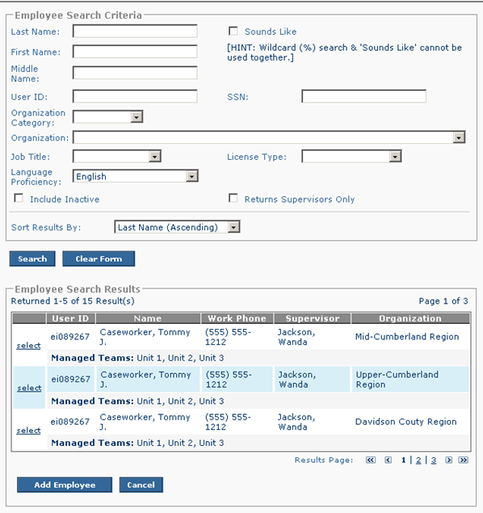
Figure 1 – Employee Search Screen – Existing Screen Mock Up

To Be – Screen Mock Up
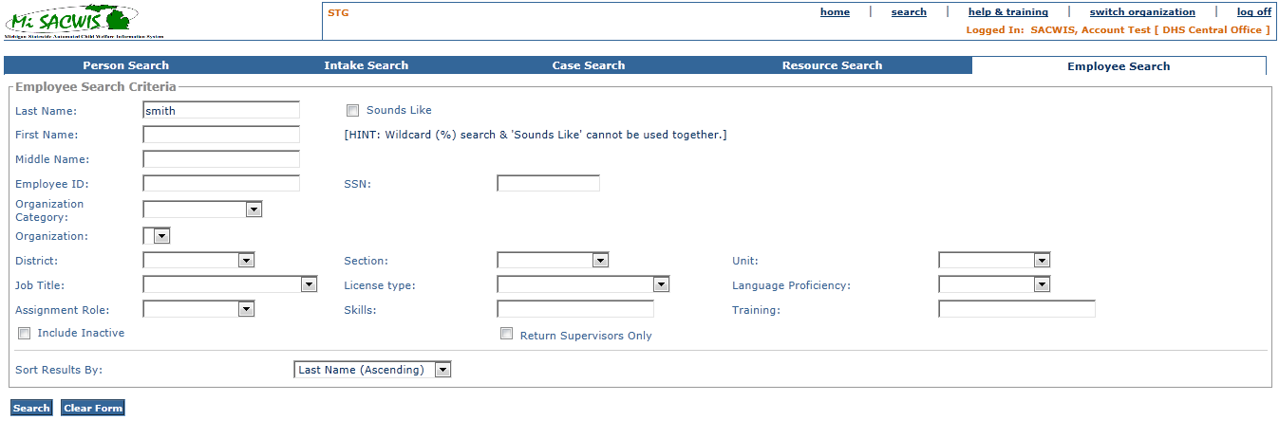
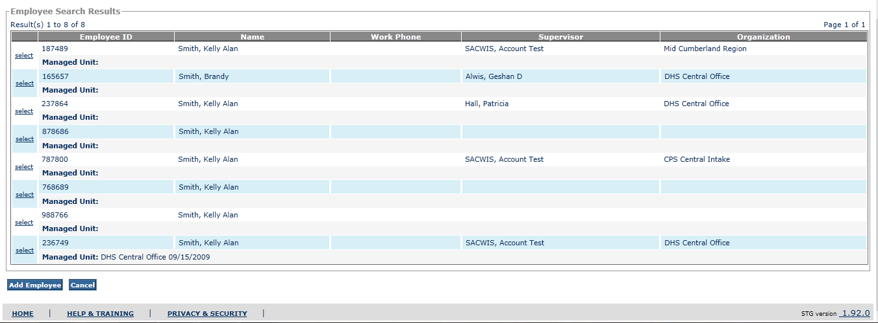
Figure 2 – Employee Search Screen – Updated Screen Mock Up

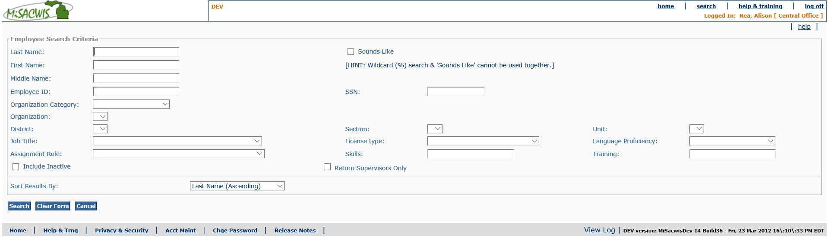

Figure 3 – Employee Search Screen (when accessed via workflow) – Updated Screen Mock Up

Screen Fields
Status (Keep/Add/Modify/Delete) | As Is  Class.Attribute Name | To Be  Class.Attribute Name | As Is  Display Name | To Be  Display Name | To Be  Type | To Be  Align | To Be Size | To Be  Read  Only | To Be  Calculation | To Be  Edit Mask | To Be  UI Validation
Keep | N/A | N/A | Employee search Criteria | Employee search Criteria | Section Header | L | N/A | T
Keep | Person.lastName | Person.lastName | Last Name | Last Name | Text Field | L | 40 | F
Keep | Person.firstName | Person.firstName | First Name | First Name | Text Field | L | 40 | F
Keep | Person.middleName | Person.middleName | Middle Name | Middle Name | Text Field | L | 40 | F
Modify | SecurityUser.infoSecID | Employee.employeeId | User ID | Employee ID | Text Field | L | 22 | F
Keep | Employee.SSN | Employee.SSN | SSN | SSN | Text field | L | 11 | F
Keep | Agency.agencyCategoryCode | Agency.agencyCategoryCode | Organization Category | Organization Category | Drop Down List | L | 100 | F | Domain Code: ‘AgencyCategory’
Keep | Agency.AgencyName | Agency.AgencyName | Organization | Organization | Drop Down List | L | 100 | F | See BR 3.1.5.4 |  | List of Organizations based on user selection in Organization Category.
Add | N/A | Employee_Work_History.DistrictCode | N/A | District | Drop down list | L | 100 | F | Domain Code:  District |  | Only Display districts associated with the user selected Organization.
Add | N/A | Emplolyee_Work_History.SectionCode | N/A | Section | Drop down list: | L | 100 | F | Domain Code:  Section |  | Only Display sections associated with the user selected Organization and District.
Add | N/A | AgencyUnit.AgencyUnitName | N/A | Unit | Drop down list | L | 100 | F |  |  | Only Display Units associated with the user selected Organization, District, & Section.
Keep | EmployeeWorkHistory.JobTitleCode | EmployeeWorkHistory.JobTitleCode | Job Title | Job Title | Drop Down List | L | 100 | F | Domain Code=’JobTitle’
Keep | ProfessionalLicense.licenseTypeCode | ProfessionalLicense.licenseTypeCode | License Type | License Type | Drop Down List | L | 100 | F | Domain Code=’LicenseType’
Keep | PersonLanguage.LanguageCode | PersonLanguage.LanguageCode | Language Proficiency | Language Proficiency | Drop Down List | L | 100 | F | Domain Code=’Language’ |  | List of language proficiencies.
Add | N/A | Role.RoleName | N/A | Assignment Role | Drop Down List | L | 100 | F | Indicates the name of the role |  | Only display values where the Assignment flag is true.
Add | N/A | TrainingPlanRecord.CommentText | N/A | Skills | Text field | L | 100 | F
Add | N/A | TrainingPlanRecord.ActualCourseTitle | N/A | Training | Text field | L | 100 | F
Keep | Employee.TerminationDate | Employee.TerminationDate | Include Inactive | Include Inactive | Check Box | L | N/A | F |  |  | Returns rows with employees where terminated date does not equal null
Keep | EmplyeeWorkHistory.UnitSupervisorID | EmplyeeWorkHistory.UnitSupervisorID | Return Supervisors Only | Return Supervisors Only | Check box | L | N/A | F |  |  | When checked the search results will only return employees that are supervising a Team
Modify | N/A | N/A | Sort results by | Sort results by | Drop Down List | L | N/A | F |  |  | Allows for selection of sort columns, both in Ascending & Descending order:  Employee ID  Last Name  Supervisor  Managed Unit  (Default value will be Last Name in Ascending Order)
Keep | N/A | N/A | Employee search Results | Employee search Results | Section Header | L | N/A | T
Modify | SecurityUser.infoSecID | Employee.employeeId | User ID | Employee ID | Display text | L | 22 | T
Keep | Person.firstName, Person.lastName, Person.middleName | Person.firstName, Person.lastName, Person.middleName | Name | Name | Display text | L | 100 | T
Keep | PartyContactMedium.partyContact | PartyContactMedium.partyContact | Work Phone | Work Phone | Display text | L | 130 | T
Keep | Person.firstName, Person.lastName, Person.middleName | Person.firstName, Person.lastName, Person.middleName | Supervisor | Supervisor | Display text | L | N/A | T | Derive data from employee’s current job
Keep | Agency.agencyName | Agency.agencyName | Organization | Organization | Display text | L | 100 | T
Modify | AgencyUnit.agencyUnitName | AgencyUnit.agencyUnitName | Managed Teams | Managed Unit | Text Field | L | 50 | T

Action Buttons/Hyperlinks
Status (Keep/Add/Modify/Delete) | Label | Type | On Click Action/Navigation
Keep | Sounds-like | Check-box | Returns rows with names that match the “sounds like” criteria
Keep | Search | Button | Returns rows that match the criteria
Keep | Clear form | Button | Clears the search criteria
Keep | Select | hyperlink | Context-sensitive hyperlink that returns control to the calling page. Default – opens Maintain Staff UC to users with the proper Business Process Security
Keep | Add employee | Button | Invokes Find a Person UC  * Not available until search is completed  * Only Displays to users with the proper Security Profile
Keep | Cancel | Button | Returns to calling use case with no returned results.  Button only appears when this screen is accessed as a sub-function from another use case. The button disappears if accessed from the Employee Search available from the Home Screen.
    - Business Rules
No. | Status (Keep/Add/Modify/Delete) | Business Rule Description | Modified Business Rule Description | Execution Event (field tab out/save etc) | Error Msg Code  To be completed by Development Team
1 | Keep | If Employee ID or SSN are used as search criteria, the search will do an exact match search on the entered data (i.e. no wild card search permitted). |  | On Search Button
2 | Keep | If Employee ID or SSN are used as search criteria, all other fields will be ignored during the search. |  | On Search Button
3 | Keep | If this use case is called from the Link Employee button on Screen 03 of CF01 - Maintain Staff Information the 'Add Employee' button on this screen will be disabled. |  | Screen Display
4 | Add | The list of Organizations will be derived from the Agency table that matches the user entered Organization Category and displayed in the drop down in alphabetical order.
5 | Add | The Skills and Training search criteria fields should allow for wild card searching.  For example, if an employee record has the value 'Knows SQL Development' for the Skills field. A user who enters the value 'SQL' in the Skills search criteria should return the above employee record in the search results.
6 | Modify | When a call is made to this Use Case from CF02 – Identify On-call Staff the Organization Category and Organization data will be passed from CF02. In addition, the field ‘License Type’ will be pre-filled with ‘New Employee Certification’ and disabled. Also, the ‘Include Inactive’ field will be unchecked and disabled. Finally, the ‘Add Employee’ button will be hidden. | When a call is made to this Use Case from CF02 – Identify On-call Staff the Organization Category and Organization data will be passed from CF02. Also, the ‘Include Inactive’ field will be unchecked and disabled. Finally, the ‘Add Employee’ button will be hidden.
7 | Keep | When a call is made to this Use Case from CF34 – Assign Delegate the ‘Returns Supervisor Only’ checkbox should be checked and disabled. The ‘Add Employee’ button will be hidden.
8 | Delete | When a call is made to this Use Case from CF01-Maintain Staff Information the ‘Returns Supervisor Only’ checkbox should be checked and disabled. The ‘Add Employee’ button will be hidden.

Screen Navigation
No. | Status (Keep/Add/Modify/Delete) | To Screen Navigation Path
1 | Keep | This screen can be accessed from a calling use case as specified in that use case.
2 | Keep | This screen can be accessed by clicking on the search hyperlink from the Home page then clicking on the Employee Search tab.

Pre-Conditions
No. | Status (Keep/Add/Modify/Delete) | Pre-Condition
 | N/A

    - Reference Values
No. | Status (Keep/Add/Modify/Delete) | To Be Class Attribute | Domain Code | Short Desc | Ref Data Code
1 | Modify | Agency.agencyCategoryCode | AgencyCategory | Central Intake | CENTRALINTAKEORG
 |  |  |  | Central Office | CENTRALOFFICEORG
 |  |  |  | DHS Residential | DHSRESIDENTIAL
 |  |  |  | DHS County Office | DHSCOUNTY OFFICE
 |  |  |  | Other | OTHER
 |  |  |  | Other State Agency | OTHERSTATEORG
 |  |  |  | Court | COURT
 |  |  |  | Private Agency | PRIVATEAGENCY
 |  |  |  | Tribe | TRIBE
2 | Add | Employee_Work_History.DistrictCode | District | Values are too numerous and complicated to display here. See MiSACWIS Reference Data Spreadsheet. | Values are too numerous and complicated to display here. See MiSACWIS Reference Data Spreadsheet.
3 | Add | Emplolyee_Work_History.SectionCode | Section | Values are too numerous and complicated to display here. See MiSACWIS Reference Data Spreadsheet. | Values are too numerous and complicated to display here. See MiSACWIS Reference Data Spreadsheet.
4 | Keep | EmployeeWorkHistory.jobTitleCode | JobTitle | Administrative/Technical Support | ADMINISTRATIVETECHSUPPORT
 |  |  |  | Case Aide/Transporter | CASEAIDETRANSPORTER
 |  |  |  | Community Resource Coordinator | COMMUNITYRESOURCECOORD
 |  |  |  | Contact Administrator | CONTACTADMINISTRATOR
 |  |  |  | Education Planner | EDUCATIONPLANNER
 |  |  |  | Foster Care Placement Worker | FOSTERCAREPLACEMENTWORKER
 |  |  |  | Health Liaison Officer | HEALTHLIAISONOFFICER
 |  |  |  | Intake Worker | INTAKEWORKER
 |  |  |  | Michigan Youth Opportunity Initiative | MICHIGANYOUTHOPPORTUNITY
 |  |  |  | Permanency Planning case Conf. | PERMPLANCASECONF
 |  |  |  | Permanency Planning Assistant | PERMPLANASSISTANT
 |  |  |  | Recruitment Workers | RECRUITMENTWORKER
 |  |  |  | Staff in CWTI | STAFFINCWTI
 |  |  |  | Title IVE/CWFS | TITLEIVECWFS
 |  |  |  | Adult Protective Services | ADULTPROTECTIVESERVICES
 |  |  |  | Adoption | ADOPTION
 |  |  |  | Children's Protective Services | CHILDRENPROTECTIVESERVICES
 |  |  |  | Foster Care | FOSTERCARE
 |  |  |  | Indian Outreach | INDIANOUTREACH
 |  |  |  | Juvenile Justice | JUVENILEJUSTICE
 |  |  |  | Prevention | PREVENTION
 |  |  |  | Therapist | THERAPIST
5 |  | ProfessionalLicense.licenseTypeCode | LicenseType | State has not yet provided these values
6 | Modify | PersonLanguage.LanguageCode | Language | African | AFRICAN
 |  |  |  | Albanian | ALBANIAN
 |  |  |  | American Indian/Eskimo | AMERINDIANESKIMO
 |  |  |  | American Sign Language | AMERICANSIGNLANGUAGE
 |  |  |  | Arabic | ARABIC
 |  |  |  | Bengali | BENGALI
 |  |  |  | Bosnian | BOSNIAN
 |  |  |  | Bulgarian | BULGARIAN
 |  |  |  | Burmese | BURMESE
 |  |  |  | Cambodian | CAMBODIAN
 |  |  |  | Chaldean | CHALDEAN
 |  |  |  | Chinese | CHINESE
 |  |  |  | Creole | CREOLE
 |  |  |  | Croatian | CROATIAN
 |  |  |  | Danish | DANISH
 |  |  |  | Dutch | DUTCH
 |  |  |  | English | ENGLISH
 |  |  |  | Farsi | FARSI
 |  |  |  | Filipino | FILIPINO
 |  |  |  | French | FRENCH
 |  |  |  | German | GERMAN
 |  |  |  | Greek | GREEK
 |  |  |  | Hebrew | HEBREW
 |  |  |  | Hindi | HINDI
 |  |  |  | Hungarian | HUNGARIAN
 |  |  |  | Indonesian | INDONESIAN
 |  |  |  | Italian | ITALIAN
 |  |  |  | Japanese | JAPANESE
 |  |  |  | Korean | KOREAN
 |  |  |  | Kurdish | KURDISH
 |  |  |  | Laotian | LAOTIAN
 |  |  |  | Macedonian | MACEDONIAN
 |  |  |  | Mong | MONG
 |  |  |  | Norwegian | NORWEGIAN
 |  |  |  | Other (Non-Eng) | OTHERNONENGLISH
 |  |  |  | Persian | PERSIAN
 |  |  |  | Polish | POLISH
 |  |  |  | Portuguese | PORTUGUESE
 |  |  |  | Punjabi | PUNJABI
 |  |  |  | Romanian | ROMANIAN
 |  |  |  | Russian | RUSSIAN
 |  |  |  | Samoan | SAMOAN
 |  |  |  | Serbian | SERBIAN
 |  |  |  | Somali | SOMALI
 |  |  |  | Spanish | SPANISH
 |  |  |  | Spanish (reads) | SPANISHREADS
 |  |  |  | Thai | THAI
 |  |  |  | Turkish | TURKISH
 |  |  |  | Urdu | URDU
 |  |  |  | Vietnamese | VIETNAMESE

